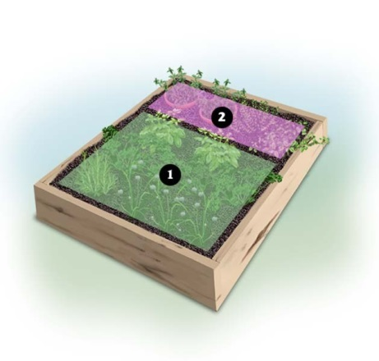



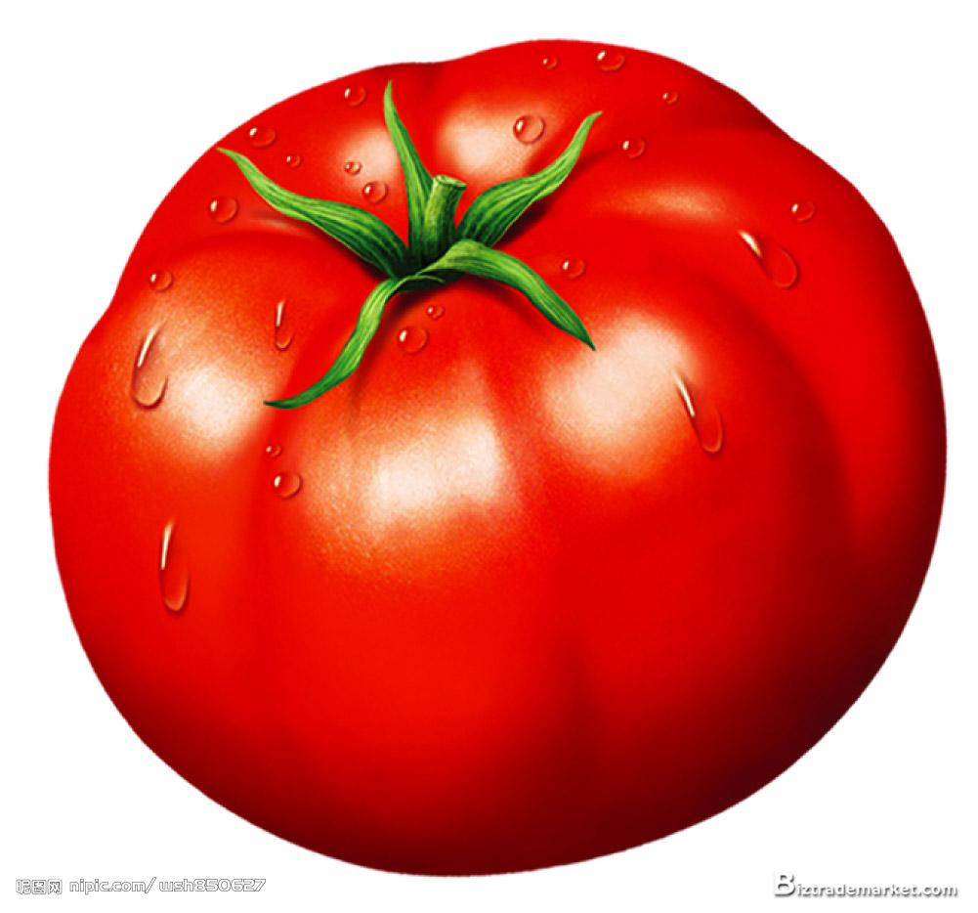

**Today in the Garden!**

Visit the garden to learn about planning your own 4ft x 4ft herb garden and pick up free herb divisions from our garden to plant at home!